**By Damian Kifuso**



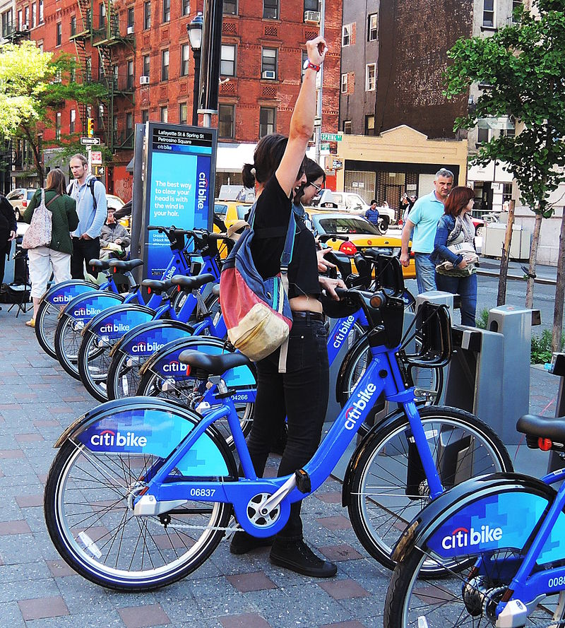

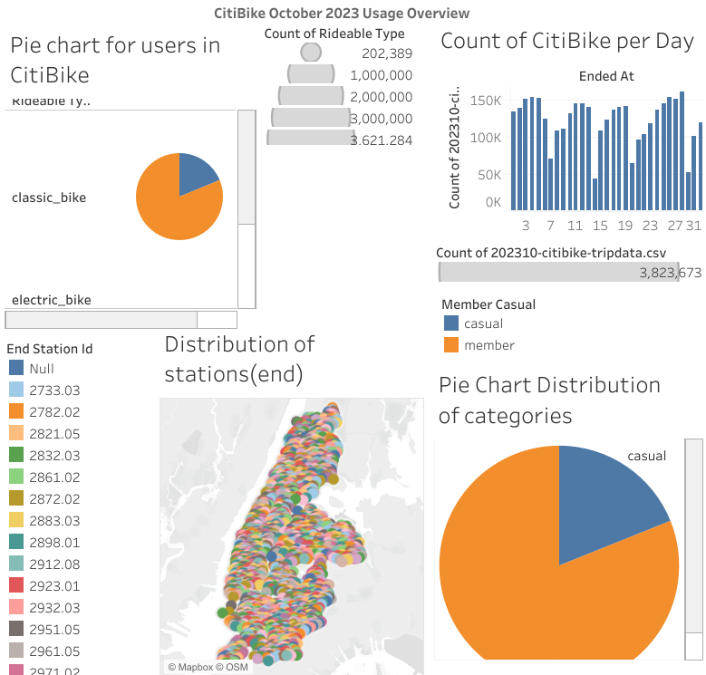

<https://public.tableau.com/views/CitiBikeDashboardOverview/DashboardOverview?:language=en-US&publish=yes&:display_count=n&:origin=viz_share_link>

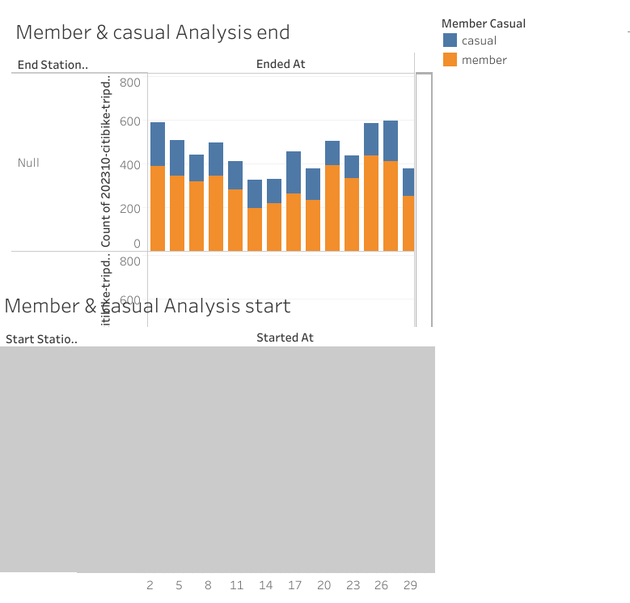

<https://public.tableau.com/views/CitiBikeDashboardOverview/MembercasualAnalysisend?:language=en-US&publish=yes&:display_count=n&:origin=viz_share_link>

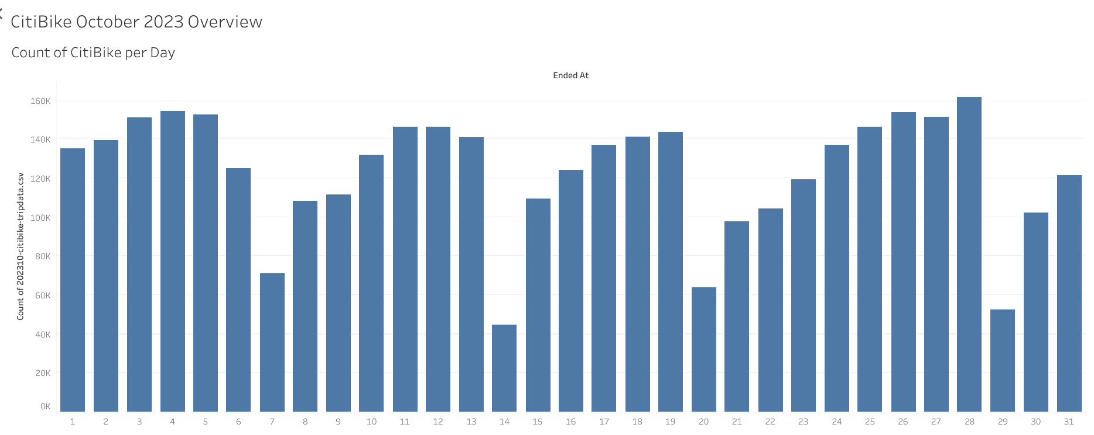

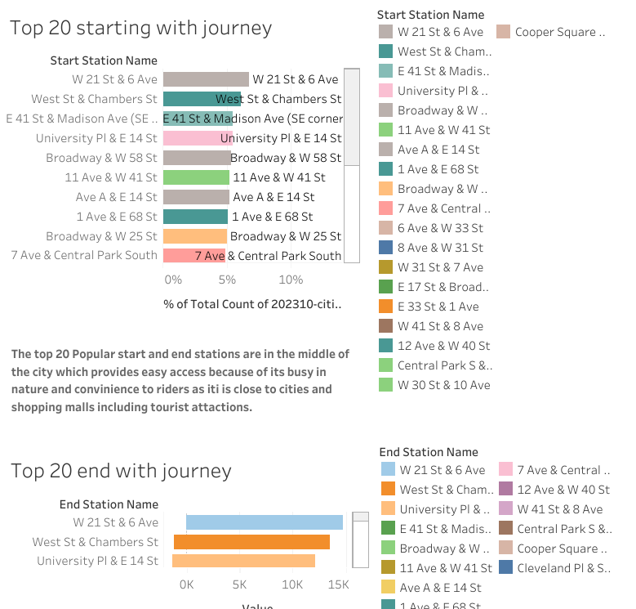

<https://public.tableau.com/views/CitiBikeDashboardOverview/DashboardOctober2023popularstations?:language=en-US&publish=yes&:display_count=n&:origin=viz_share_link>

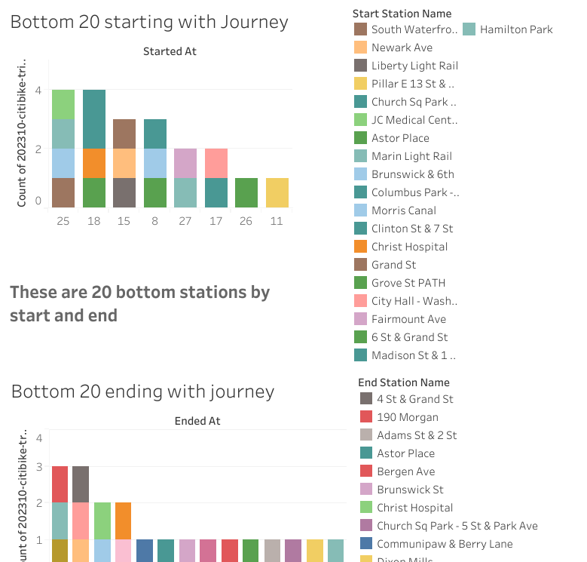

<https://public.tableau.com/views/CitiBikeDashboardOverview/DashboardOctober202320Bottomstartingandending?:language=en-US&publish=yes&:display_count=n&:origin=viz_share_link>

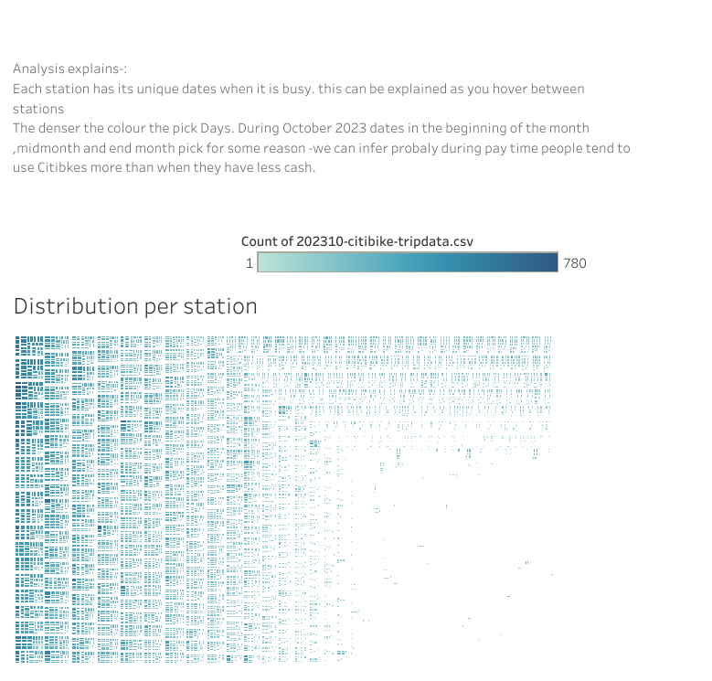

<https://public.tableau.com/views/CitiBikeDashboardOverview/DashboardDistributionperstation?:language=en-US&publish=yes&:display_count=n&:origin=viz_share_link>